

IS4250 Healthcare Analytics

Health-Related Lifestyle Behaviors among Male and Female Rural-to-Urban Migrant Workers in Shanghai, China

Chen Jiesheng (A0099515U)

Xia Jingyi (A0100125H)

# 1. Introduction

## 1.1 Paper Background

This *paper Health-Related Lifestyle Behaviors among Male and Female Rural-to-Urban Migrant Workers in Shanghai, China* is a cross-sectional study between August and October 2012 during which lifestyle behaviors of migrant workers participating in Shanghai are collected and studied. Furthermore, researchers also explored the association between lifestyle scores and contributing demographic factors such as employment, salary, mental health, marital status, and migratory history.

The study subjects are rural-to-urban migrant workers in China, underpinning the unprecedented urbanization movements in human history. According to National Bureau of Statistics of China, there was a total of 252.78 million migrant workers in 2011[1]. By 2025, this number is expected to increase by another 243 million.[2]

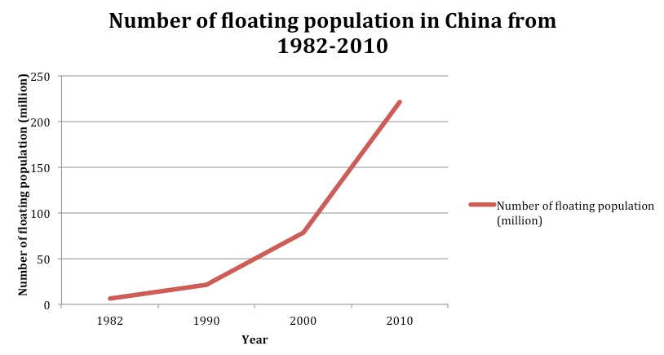

Fig 1 Number of floating population/ migrant workers in China[3]

Migrants in China form the floating population in urban areas. The reason for leaving rural areas to take up jobs in urban area is largely economic. As the economy is booming and coastal cities in China enjoy an astonishing annual growth rate of over 10%, migrant workers can earn much more income in cities than in rural areas. In general, rural-to-urban migrant workers take up laborious manual work in cities because they have received less education in rural areas. Fig 2 compares education levels between urban job seekers and migrant workers. The heavy manual work together with their lack of healthcare programs/ insurance in urban areas makes health problems a looming issue to migrant workers.

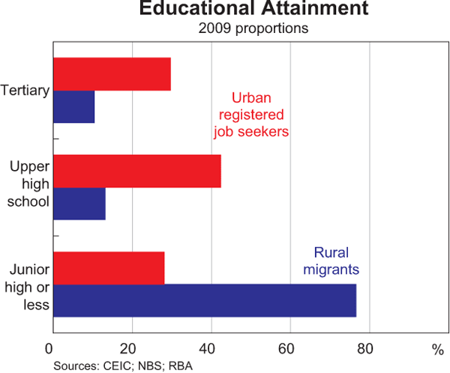

Fig 2 Education Attainment Comparison

Shanghai is the economic center in China, attracting 6 million migrants annually. By studying the health status of the migrant workers in Shanghai, researchers can shed important lights on the overall health condition of migrant workers in China.

## 1.2 Literature Review

Several previous biomedical papers have influenced and inspired the study of this paper. In *Chronic diseases and health promotion[4]* and *Health factors and longevity in men and women: a 26-year follow-up study[5]*, health-related lifestyle behaviors are found to be important determinants of disease. In *Patterns of unhealthy behaviour in Finland[6]*, numerous lifestyle behaviors that have impact on health are identified: cigarette smoking, alcohol consumption, physical activity, and diet. And the concept of health scores based on assessment of health-related lifestyle behaviors is first proposed by *Relation between modifiable lifestyle factors and lifetime risk of heart failur[7].* It is evident to see how previous literatures shape the basic ideas and methods of this paper.

In recent years, several literatures have studied the prevalence of infectious diseases, mental health, quality of life and smoking in the migrant workers in China. However, no papers applied the study of lifestyle behavior on migrant workers. As such, the researchers are encouraged to fill in the gap and advance the medical study to a new level: to identify relationships between health scores based on lifestyle behaviors and demographic information of migrant workers.

## 1.3 Purpose of the Paper

Our group identifies three major purposes of the paper:

1. To study the health condition of rural-to-urban migrant workers, a group of people who might have potential health issues due to their job nature and a group of people who received limitation attention in previous biomedical studies
2. To identify the association of health scores, determined by lifestyle behaviors, and demographic information such as occupation and diet information

## 1.4 Research Methods

## 1.5 Collection of Data

# 2. Statistical Analysis and Results

## 2.1 Statistical Analysis Results

## 2.2 Replicate of One Experiment Plot

# 3. Evaluation of the Paper

## 3.1 Conclusions

## 3.2 Challenges

## 3.3 Limitations

## 3.4 Contributions

1. National Bureau of Statistics of China (2012): "Statistical Communiqué on the 2011 National Economic and Social Development" <http://www.stats.gov.cn/english/NewsEvents/201202/t20120222_26575.html> .
2. Shanghai, Geoff Dyer in (2008-03-23). ["China braced for wave of urban migrants"](http://www.ft.com/cms/s/0/c11a84ca-f902-11dc-bcf3-000077b07658.html). *Financial Times*. [ISSN](https://en.wikipedia.org/wiki/International_Standard_Serial_Number) [0307-1766](https://www.worldcat.org/issn/0307-1766).
3. Statistical data are adapted from Zai Liang’s presentation in the United Nations in 2012, titled Recent Migration Trends in China: Geographic and Demographic Aspects and Development Implications, as quoting the Tabulation on the Population Census of China in 1982, 1990, 2000 and 2010, published by China’s National Bureau of Statistics.
4. Centers for Disease Control and Prevention (2013) Chronic diseases and health promotion. Available:

   http://www.cdc.gov/chronicdisease/overview/index.htm.
5. Carlsson AC, Theobald H, Wandell PE (2010) Health factors and longevity in men and women: a 26-

   year follow-up study. European journal of epidemiology 25: 547–551. doi: 10.1007/s10654-010-9472-2

   PMID: 20623324
6. Laaksonen M, Prattala R, Karisto A (2001) Patterns of unhealthy behaviour in Finland. Eur J Public

   Health 11: 294–300. PMID: 11582610
7. Djousse L, Driver JA, Gaziano JM (2009) Relation between modifiable lifestyle factors and lifetime risk of heart failure. JAMA: J Am Med Assoc 302: 394–400.